Terrific Teen Programs
RoseMary Honnold
honnolro@oplin.org

Teens Today!
"The children now love luxury; they have bad manners, contempt for authority; they show disrespect for elders and love chatter in place of exercise. Children are now tyrants, not the servants of their households. They no longer rise when elders enter the room. They contradict their parents, chatter before company, gobble up dainties at the table, cross their legs, and tyrannize their teachers." ~Socrates 469-399 B.C.~

The 40 Developmental Assets
The 40 building blocks of healthy development that help young people grow up healthy, caring, and responsible. ~The Search Institute~
External Assets
Young people receive external assets from the people and institutions in their lives.
Support, Empowerment, Boundaries and Expectations, Constructive Use of Time
Internal Assets
Internal Assets are the internal qualities that guide positive choices and foster a sense of confidence, passion, and purpose.
Commitment to Learning, Positive Values, Social Competencies, Positive Identity
The Ten Developmental Assets Teens Experienced Least Often
Cultural Competence 35%
Parent Involvement in Schooling 29%
Planning and Decision Making 29%
Adult Role Models 27%
Positive Family Communications 26%
Caring School Climate 25%
Youth as Resources 25%
Reading for Pleasure 24%
Community Values Youth 20%
Creative Activities 19%
The Key to Building Assets
Teens with more assets exhibit more positive behaviors
Teens with fewer assets are more likely to engage in risky self-destructive behaviors- drug use, unsafe sex, and violence
Building relationships with non-parental adult role models is the key to help teens build assets
It takes TIME to build relationships
Find ways to spend time with the teens in your library
The Search Institute. “The Forty Developmental Assets for Adolescents” [Online] Available: www.search-institute.org/assets/forty.html.
Kimball-Baker, Kathleen. 2003. Tag, You're It! 50 Easy Ways to Connect with Young People. Minneapolis, MN: Search Institute

Teens and Resiliency
Average or above cognitive skills and a pleasing social disposition
Affectionate and warm ties with adults who help the youth develop trust, autonomy, and initiative
Able to rely on supportive organizations, schools, youth groups, churches
Libraries and Teen Resiliency

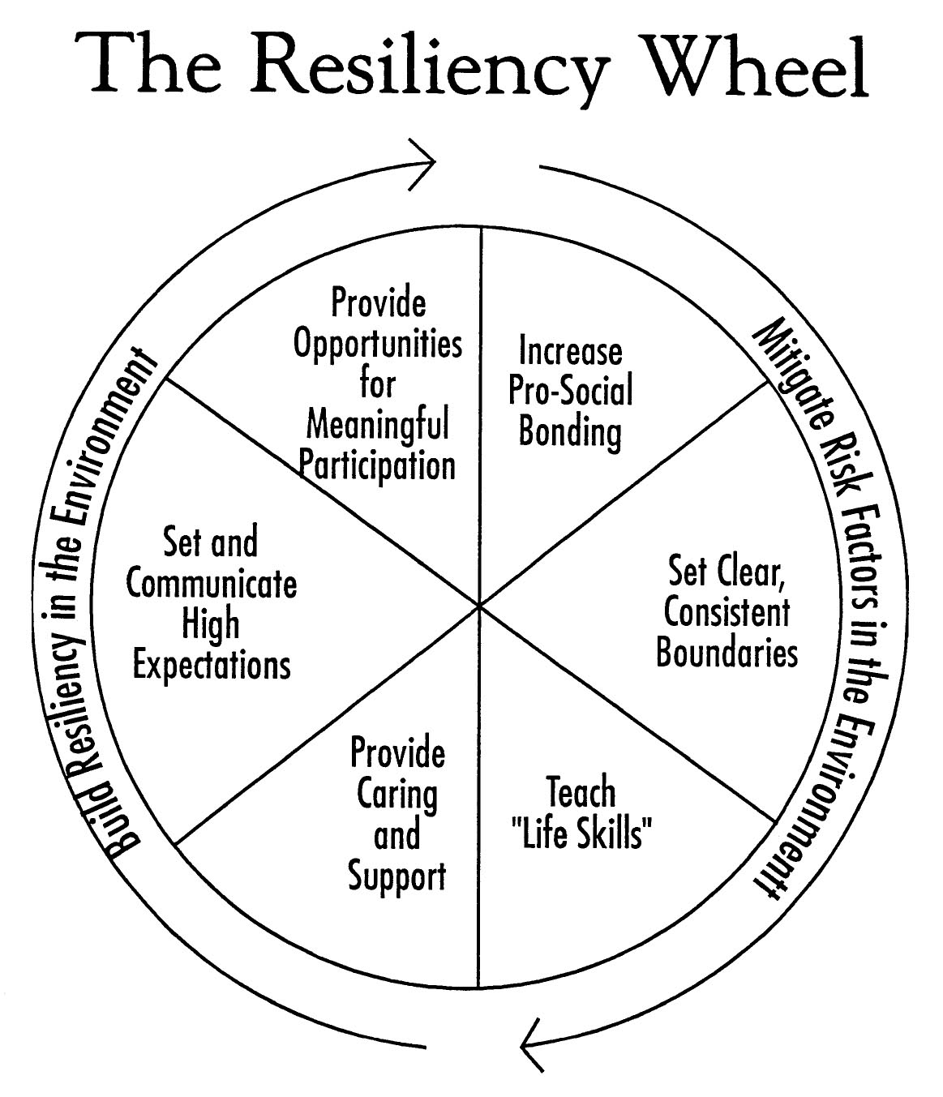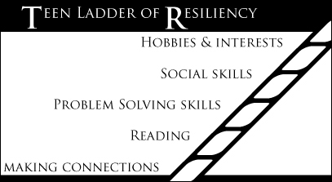

Jones, Jami L. “Ask Dr. Jami” [Online] Available: www.askdrjami.org/resiliency.html
Jones, Jami L. “Somewhere to Walk and Someone to Walk With” Voice of Youth Advocates 22 (February 2007): 495-498.

Librarians Who Are Booklovers
Summer Reading Programs
Book Discussion Groups
Genre Book Clubs

Movies and TV
Speakers
Detective Activities
Plan and Host Mystery Events
Play Games
Writing
Internet

Animanga Club

Japanese cooking lesson
Create orderlists of manga and anime
Manga drawing lessons
Preview anime
Cosplay
Anime marathons
JET speaker
Jeopardy trivia games
Samurai soldiers
Japanese language lesson
Martial arts demo
Video games
Japanese calligraphy
Operation Anime at www.operationanime.com
The Right Stuf at www.rightstuf.com

Teens Talk Books

Pass It On
Book games
Book talk
New books
Readathon “All You Can Read Buffet”

Book Discussion Groups
"...kids are living stories every day that we wouldn't let them read." ~Josh Westbrook~
Online Book Reviews by Teens
Poster Matching Games

Book Series/Characters
Book Series/Fantasy Worlds
Authors/Characters
TV shows/Characters
Movies/Actors
Songs/Performers
First Lines/Titles

Promote Reading
Booktalking in schools
Book talking and displays at TAB meetings and programs
Library Thing at www.librarything.com
GoodReads at www.goodreads.com
Podcast reviews
Book Shopping
Author Visits

Booklists

Popular Paperbacks[Online] Available: www.ala.org/yalsa/booklists/poppaper

VOYA [Online] Available: www.voya.com

Audio Books [Online] Available: www.ala.org/ala/yalsa/booklistsawards/selectedaudio/selectedaudiobooks.cfm

SRP Manual bibliographies

Yalsa-Bk [Online] Available: http://lists.ala.org/wws/info/yalsa-bk
Honnold, RoseMary. 2006. The Teen’s Reader Advisor New York: Neal-Schuman.
Librarians Who Are Creative
Papermaking
Picture Frames
Soaps, Lotions, and Bath Salts
Butt Pillows
Tie Dye
Beads, Beads, Beads
Drawing Classes
How to Do Mehndi Henna Tattoo
- Choose a design.
- Wash the skin to be tattooed with a cotton ball and lemon juice to remove skin oils and lotions. Dry skin.
- Apply henna. Let dry.
- Apply lemon sugar glaze to seal henna to skin for at least 2 hours. Reapply as needed. The longer you leave the henna on, the darker your tattoo will be.
- Scrape off henna and apply any vegetable oil or essential oil, NOT baby oil. Your tattoo will be pale orange at first and darken over night to a reddish brown.
The best sites I’ve found for supplies and information: The Henna Page [Online] Available: http://www.hennapage.com/ Mehandi [Online] Available: http://www.mehandi.com/
Create-a-Card
Candymaking
Altered Books
Hardware to Hardwear
Books for Transforming Crafts:
Rogge, Hannah and Marianne Rafter. 2006. Hardwear: Jewelry from a Toolbox. STC Craft/Melanie Falick Books; Spi edition.
Brazelton, Bev. 2004. Altered Books Workshop: 18 Creative Techniques for Self-Expression. North Light Books; 1st edition.
Byers, Dorie. 2001. Natural Beauty Basics : Create Your Own Cosmetics and Body Care Products. Vital Health Publishing; 2 Revised edition.

Meyrich, Elissa. 2006. Rip It!: How to Deconstruct and Reconstruct the Clothes of Your Dreams. Fireside.
Nicolay, Megan. 2006. Generation T: 108 Ways to Transform a T-Shirt. Workman Publishing Company.
Ivarsson, Anna-Stina Linden. 2005. Second-Time Cool: The Art of Chopping Up a Sweater. Annick Press.
Rogge, Hannah. 2007. Save This Shirt: Cut It. Stitch It. Wear It Now! Stewart, Tabori & Chang; Spi edition.
Paint the Library Red, White, and Blue
Catch the Duct Tape Bug
Pimp? My Bookcart
[Online] Available: www.unshelved.com/pimpmybookcart/

Instructions for Spirit House
The Spirit House craft is inexpensive and creative and goes nicely with the Metamorphosis theme of changing on the inside and outside. The inside and outside should be in different color themes to be effective.
- Cut 6 four inch squares of sturdy poster board or Bristol board.
- Decorate one side of each square with paints, rubber stamps, stickers, glitter, etc to represent your outside personality, family, pets, school, hobbies, activities, etc. Allow to dry.
- Flip over all squares and decorate to reflect your inner self, your hopes and dreams, plans for the future. Allow to dry.
- Line up your squares like this:

- Punch matching holes along adjoining sides. Two to three holes per side to lace or tie sides together.
- Lace or tie sides together using fiber, twine, ribbon, string…. Use your imagination.
- String 5 or 6 beads on the same fiber you used for the hinges and attach to the “lid” sides of the house.
- Brush on a coat of Mod Podge or other sealer to preserve your work.
- Fold into a cube.

Folding Scrapbooks Instructions
Folding scrapbooks are quick, clever, and fun to make. You can make them very inexpensively, or indulge in fancy acid-free papers. Making them is just the beginning of the fun; filling them is the bonus exciting part of the project. You might plan your scrapbook around a theme, such as a sport or hobby, or fill it with mementos from a vacation. Collect school photos of friends and ask them to sign your book for a keepsake autograph book. Use gel pens, photos, clippings, and stickers for decorating.
You will need paper and lightweight cardboard for the covers, paper for the folding pages, and 30" of ribbon, a glue stick or double-sided tape. Heavier gift wrap works well for the decorative cover paper, poster board or discarded file folders works well for the lightweight cardboard. Card stock works well for the inside pages. Scrapbooking quality papers can be used but will cost more.
- To make the covers: Cut 2 pieces of cardboard 4 3/4" x 4 3/4". Cut 2 pieces of cover paper 6" x 6". Center and glue the cardboard square on the back of the paper squares. Cut the paper diagonally at the corners, apply glue or tape around the edges, and fold over the paper tightly on all four sides. Glue or tape the piece of ribbon across the center of one of the covers on the unpapered side.

- Cut three 8 1/2" squares of the inside paper. Fold each sheet into quarters. Flip over and fold once diagonally.
- Place two of the sheets in front of you, diagonally, corner to corner, diagonal fold in a vertical position relative to you and with the crease up. Flip the other piece over and position so that it overlaps the first two sheets. Glue or tape the overlapping squares, lining up fold lines. 
- Fold the pages flat into a square: Fold the top and bottom tips of sheet 1 and 3 toward you and the tips of the middle sheet away from you, so it will fold flat into a square. Glue or tape a cover onto the front and back. Press together and tie the ribbon.
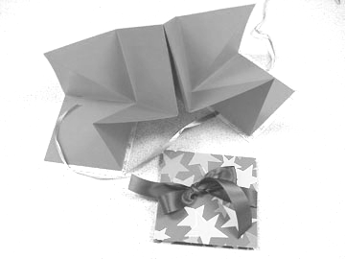
- Open and decorate your scrapbook!

Librarians Who Are Writers
Writing Contests
Short story
Flash Fiction <1000
Drabbles 100 words
Nanofiction 55 words
Poetry
Haiku
Journal/Book Making
Teen Poetry Night
Writing Workshops
Teen Writers Club
Monthly Meetings
Writing Prompts
Share writing
Share tips and resources
Contests
Blog
Become an Author
Articles: Have an idea for an article about teen services? Send article ideas to YALS: the Official Journal of the Young Adult Library Services Association. yalseditor@gmail.com (I’m the current editor!)
Books: Have an idea for a book about teen services? Send book ideas for the teens @ the library series by Neal-Schuman Publishers to honnolro@oplin.org (I’m the series editor)

Discussion Lists: ya-yaac discussion list [Online] Available: http://lists.ala.org/wws/info/ya-yaac
Blogs: www.blogger.com

Wikis: Library Success Wiki [Online] Available: www.libsuccess.org/
SHARE WHAT YOU KNOW!

Librarians Who Are Stars (or Wannabe)
Readers Theatre
Shepherd, Aaron. Aaron Shepherd’s RT Page. [Online] Available: http://www.aaronshep.com/rt/

Whose Line is It Anyway/Improv
Photo Displays
Filmmaking
Cosplay
Poetry Slams
Karaoke
Mystery Dinners
Dinner and a Murder (Death by Chocolate Cake recipe) www.dinnerandamurder.com/
Plano Public Library System. Teen Mystery Information [Online] Available:
http://www.planolibrary.org/children/TeenMysteryResource.htm
Merri Mysteries: www.merrimysteries.com/tmm/myst.htm
Whodunnit Mystery Games: www.whodunnitmysteries.com/
How To Host a Teen Mystery Game: www.djmcadam.com/teen-mystery.html
Anyone's Guess Mystery Games: www.highsmith.com/
Live Clue: www.cplrmh.com/clue.html

Librarians Who Are Guys
Game Tournaments
Monopoly Tournament [Online] Available: www.hasbro.com/monopoly/pl/page.tournaments_info/dn/default.cfm
Games in the Library
Clue
Risk
Chess
Independent Sports Games
Role Playing Club

Dungeons & Dragons
Yu-Gi-Oh
Magic
Warhammer

Librarians Who Are Techies
Teen Tech Club

Lan Parties
Software lessons/contests
Plugged and Unplugged
Internet
Wii
PS2
Movies
Board Games
Refreshments
- Plugged and Unplugged meets Wednesday afternoons after school, 2-5 pm.
- We use the laptop computer lab, a Nintendo wii, and a Playstation 2 and sometimes a teen brings in an additional game console. The lab was acquired several years ago with an LSTA grant, the wii was purchased with a local Coshocton Foundation grant, The Playstation 2 and several games with a Wal-mart grant. Additional equipment with a Kiwanas grant.
- Some weeks we also show a movie with a video projector and a DVD player. Our movie license is with www.movlic.com
- Sometimes we use the video projector for a dance pad game I ordered for $6.95 (shipping) from Kraft. The games were downloaded for free and it is hooked up to a laptop. http://www.kraftbrands.com/activegame/
- Refreshments are provided with funds from the Friends of the Library. I serve pizza, pizza rolls, bagel pizzas, hot dogs, chip type snacks, cookies, carrots, grapes, granola bars or rice krispie treats all from Aldi’s, much less expensive than our other local groceries. They love when I bake break-apart cookies.
- A few issues… 1. mess …. I withheld refreshments one week and a sign said “the kitchen is closed due to the mess you left me last week!” That seemed most effective. 2. two games were stolen… now teens must sign out and return games to me. 3. a fight… a teen was banned for remainder of the school year.
- The teens love this program and worry that I won’t have it on a snow day or when one of the issues occurred that I might decide to not have it anymore! Twenty five to 40 teens attend every Wednesday.
- Favorite games right now are Rock Band, Guitar Hero, Super smash Brothers, Bleach.
Dance Dance Revolution
LAN and Online Parties
Runescape [Online] Available: www.runescape.com
Computer Free Time
Database and Search Instruction
Jeopardy

Create a template, Use for any trivia game or Battle of the Books, Add pictures, sounds, music, Play in teams. Try Etiquette Jeopardy on SRP CD. My Jeopardy games are available at www.cplrmh.com.
More Tech Programs
Digital Photo contest, pair up with workshop
MySpace safety dealing with online bullying.
Blogs: CPL’s Teen News Blog is at http://yablog.coshoctonlib.org/teenblog.html
Podcasts
Wikis

Librarians Who Are Volunteer Makers
Teen Advisory Board
Honnold, RoseMary. “The Who, What, Where, When, and How to Manage a Teen Advisory Board” [Online] Available: http://www.cplrmh.com/tab.html
Matte, Lisa. “Libraries and Teen Advisory Groups” [Online] Available: http://www.jervislibrary.org/yaweb/TAGs.html
Miller, Steve. Teen Advisory Groups - Advisory Discussion (TAGAD-L) A Discussion forum for the advisors of any public library teen advisory group. Send an email to tagad-l-subscribe@topica.com
Tuccillo, Diane. 2004. Teen Library Advisory Groups: A VOYA Guide. Lanham, MD: Scarecrow Press.
YALSA. TAGS - Teen Advisory Group Site: helping teens make their mark on libraries. Available: http://www.ala.org/ala/yalsa/tags/tags.htm
Library Helpers
Community Projects
Friends’ Helpers
Change on the Inside
Meditation
Spirit House
Healthy eating
Intergenerational Programs
Crafts
Readers Theatre
Science Fair
College Knowledge
Game Nights
Hobby Workshops
Tutoring
Battle of the Bards
Children’s Programs

Librarians Who Love a Party
End of SRP Events
Group Games
Dance Dance!
Lock-ins

Librarians Who Work with Tweens
Makeovers
Safety Demos
Mother/Daughter Bookclub

Programming Considerations
Space: library or nearby facility
Budget: food, speakers, equipment, license
Audience: age, gender, and number of teens
Resources: supplies, speakers, your own talents
You: expectations, noise and mess tolerance

Check out my books, articles, and website

Honnold, RoseMary. 2002. 101+ Teen Programs That Work. New York: Neal-Schuman.
Honnold, RoseMary for the Young Adult Library Services Association. 2007. Get Connected: Tech Programs for Teens. New York: Neal-Schuman.
Honnold, RoseMary. 2005. MORE Teen Programs That Work. New York: Neal-Schuman.
Honnold, RoseMary. 2006. The Teen’s Reader Advisor New York: Neal-Schuman.
Honnold, RoseMary. “See YA Around: Library Programming for Teens” [Online] Available: http://www.cplrmh.com.
Honnold, RoseMary. "Reading Rocks Music Review" VOYA Vol. 24, No. 5. October 2001.
Honnold, RoseMary. "Creating a Space for Teens at Your Library" Youth Activities Calendar OLC YASD Annual Publication 2001.
Honnold, RoseMary. "Active Teen Advisory Board Gets Results" Ohio Libraries. Fall 2003.
Honnold, RoseMary. "Connecting Teens with Generations A-Z: Intergenerational Programs with Teens" Public Libraries. Sept/Oct 2004
Honnold, RoseMary. "Program Possibilities: Teens Make Holiday Gifts @ the Library" YAttitudes: The official newsletter of the Young Adult Library Services Association, a division of the American Library Association Vol 4, No 1, Fall 2004.
Honnold, RoseMary. "Get Teens Active @ your library!" YALS Summer 2006.
Honnold, RoseMary. “Get Connected with Teens and Technology” State Library of Ohio Newsletter. 2007.
Honnold, RoseMary. "Marketing Awards Books" The Official YALSA Awards Guidebook Compiled and Edited by Tina Frolund. 2007.
Honnold, RoseMary. "Beyond Book Clubs" VOYA Vol. 31 No. 1 April 2008. Online Available: http://pdfs.voya.com/VO/YA2/VOYA200804BeyondBookClubs.pdf

More Helpful Resources
Naeir [Online] Available: http://www.naeir.org/ (pay membership fee and shipping). This is the source I use for most prizes, decorations and party supplies. Example: our library spent $1200 on membership and shipping for one year and received over $10,000. worth of products for all departments.
YALSA. Teen Read Week. [Online] Available: http://www.ala.org/teenread/
YALSA. Teen Tech Week. [Online] Available: http://www.ala.org/ala/yalsa/teentechweek/

Ice Breaker Idea
M&Ms or Skittles: Give each teen a small package of M&Ms or Skittles and instruct them they can eat all but one color. They must then answer the question coded with the color of the candy they saved: (Make up your own questions or use the following)
Red: What is your favorite book and why?
Orange: What was the last movie you watched and how was it?
Yellow: Who is your favorite musical group and which of their songs is your favorite?
Green: Do you have a collection? What is it and how old were you when you started it?
Blue: Which foreign country would you like to visit and why?
Brown (Purple): What is the best vacation you've ever been on?

